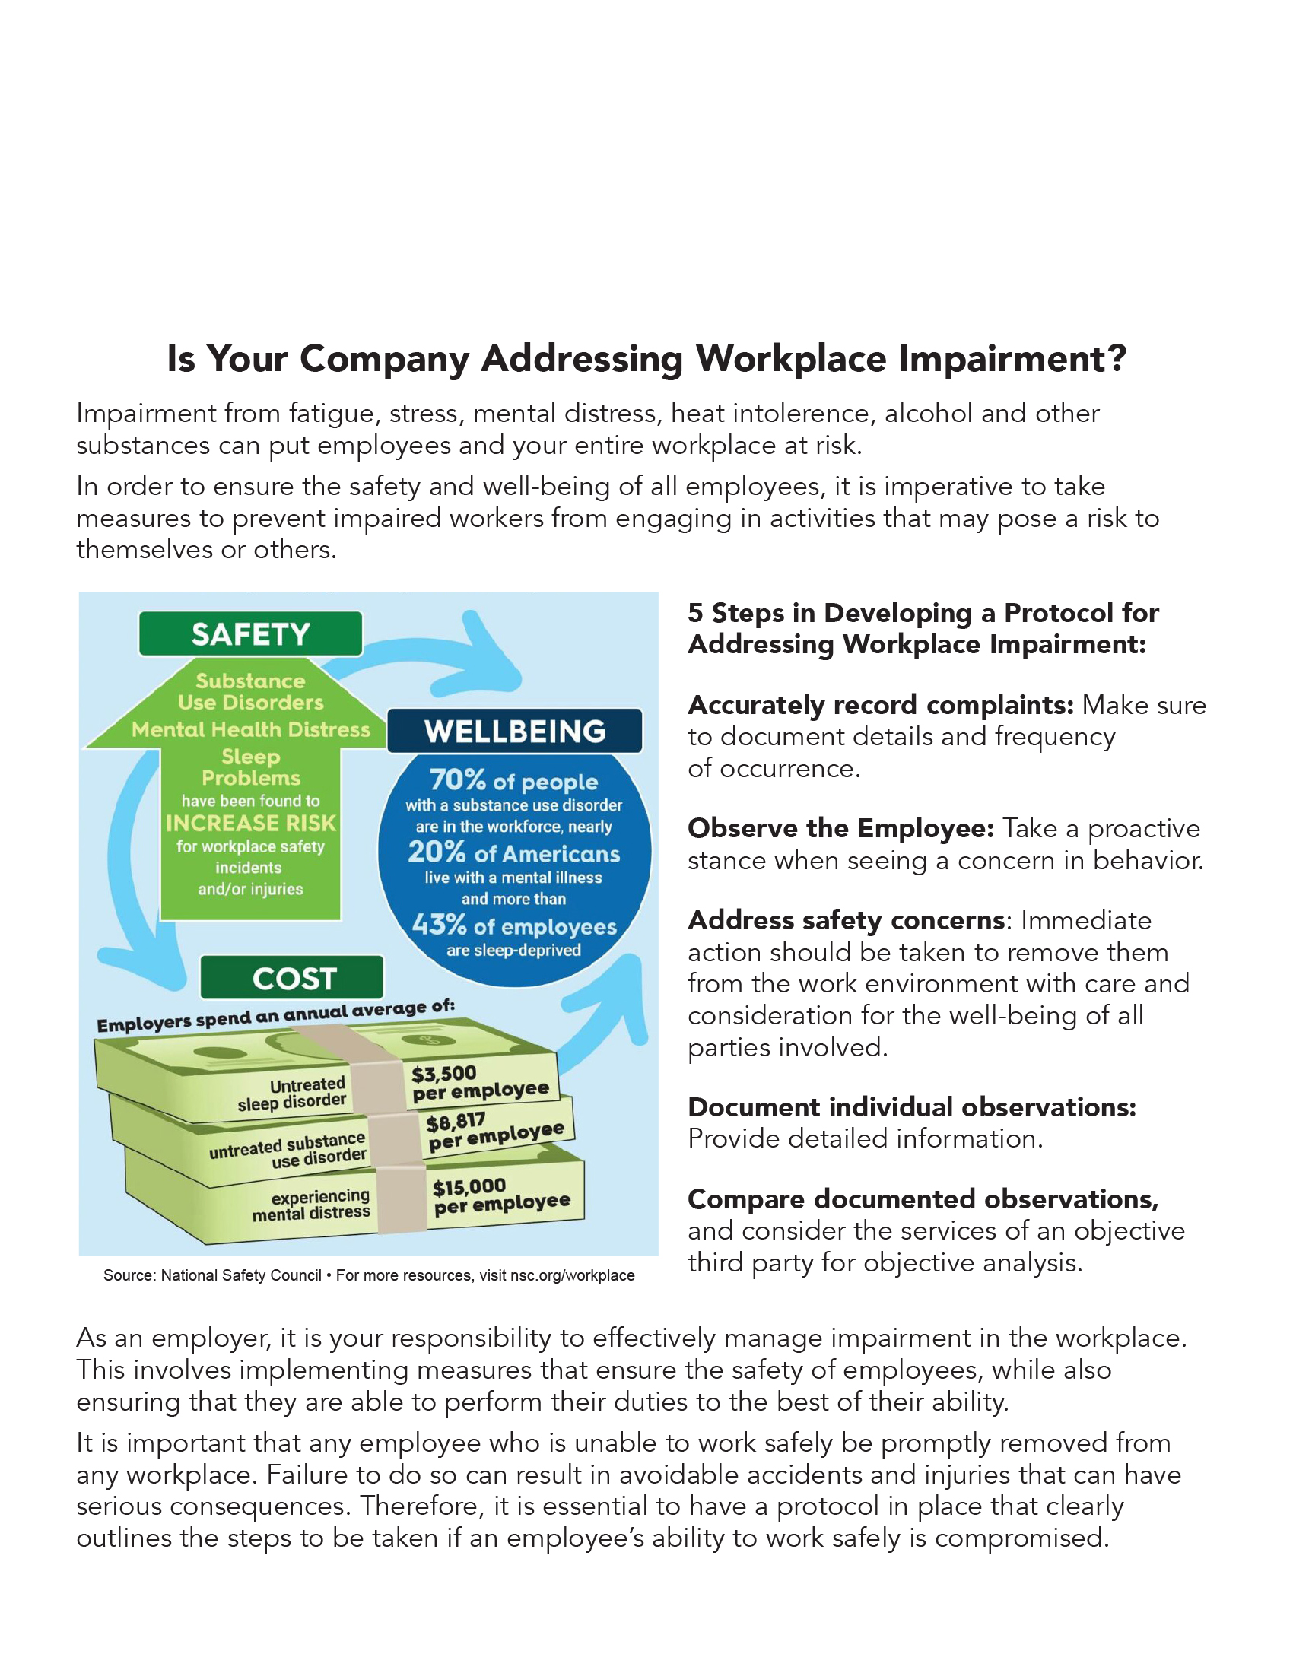

In Partnership with
Agency Line One
Agency Contact Line Two
Agency Contact Line Three



