
Rebar Caps

Beware of unguarded protruding steel reinforcing bars (REBAR) or other similar objects. They are hazardous!
If someone stumbles and falls onto unguarded rebar, impalement can result in serious internal injuries or death. Therefore, access to any construction area needs to be controlled! Employees and other people should not be allowed to access areas where these hazards exist or work above any vertically protruding hazards, such as rebar.
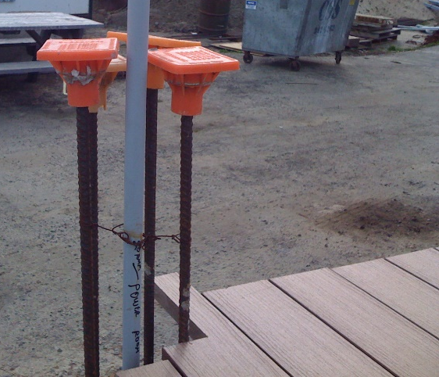
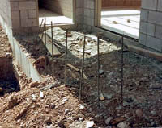
Hazard Exists! Hazard Controlled!

How to avoid hazards:
- Control access to hazard areas.
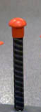
- In addition, all such hazards must be protected to eliminate impalement. The top of the vertical protrusion or rebar must be covered with an approved capping device. Guard all protruding ends of vertical protrusions, including steel rebar, with only approved rebar caps or wooden troughs, or bend rebar so that exposed ends are no longer upright and do not present an impalement hazard. Ask your Safety representative for assistance as needed.
- Only use rebar caps designed to provide impalement protection, such as those containing steel reinforcement and designed for impalement protection are to be used. Mushroom-style caps do not provide adequate protection and are disallowed. These caps were designed to provide scratch protection only and were never intended to prevent impalement, even at grade. Assure that your covers are steel reinforced, or that approved wooden troughs are in use and have been approved by regulatory groups.

SAFETY TALK SIGN IN SHEET

This form documents that the training specified above was presented to the listed participants. By signing below, each participant acknowledges receiving this training.

Organization:

Trainer: Trainer’s Signature:

Class Participants:

Name: Signature: Date:

Name: Signature: Date:

Name: Signature: Date:

Name: Signature: Date:

Name: Signature: Date:

Name: Signature: Date:

Name: Signature: Date:

Name: Signature: Date:

Name: Signature: Date:

Name: Signature: Date:

Name: Signature: Date:

Name: Signature: Date:

Name: Signature: Date:

Name: Signature: Date:

Name: Signature: Date:

Name: Signature: Date:

Name: Signature: Date:

