
Housekeeping in Construction Environments
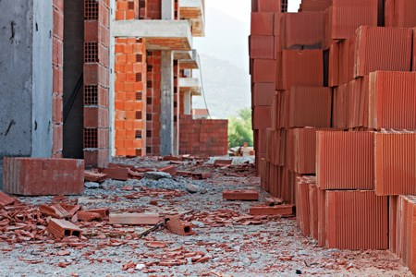
Good housekeeping is an integral practice to ensure a safe construction environment.
During the course of the workday, you might find yourself walking around or tripping over lumber, electrical cords, or tools in an area that was previously clear, making it difficult to work safely and efficiently.
Housekeeping is not just a rainy-day task or a once-a-month chore, but a job that must be done hour by hour.
General Housekeeping:
- Store supplies away from walkways to prevent trips
- Put away tools and equipment when not in use.
- Never leave tools or other building materials on surfaces where they can fall on workers if accidentally bumped or otherwise disturbed
- Dispose of construction debris in a timely manner.
- Always clean up sharps such as loose nails or saw blades as soon as possible, and store/dispose of them in a manner that eliminates the possibility of injury when handling refuse, e.g., coffee cans, buckets, or similar puncture-resistant containers.
- Keep aisles, stairways, and doorways unobstructed.
Walking Surfaces:
- All walking surfaces must be free of irregularities, such as holes and depressions. Alert your supervisor about any floor damage immediately.
- Maintain flooring and walkways to be in clean, dry, and smooth condition.
- Do not allow floor covers or mats to bunch up or fold, creating a trip hazard.
- Wear slip-resistant footwear and post caution signs in damp areas.
Hazard Communication
Use signs, tape, and other barriers to establish awareness or restrict access to the following:
- Slip, trip, or fall hazards that cannot otherwise be eliminated.
- Multi-level fall hazards such as holes in the floor or open ledges that cannot otherwise be eliminated.
- Areas where sharps are present, or high-velocity / powder-actuated nail guns or other hazardous equipment are used.
SAFETY TALK SIGN IN SHEET

This form documents that the training specified above was presented to the listed participants. By signing below, each participant acknowledges receiving this training.

Organization:

Trainer: Trainer’s Signature:

Class Participants:

Name: Signature: Date:

Name: Signature: Date:

Name: Signature: Date:

Name: Signature: Date:

Name: Signature: Date:

Name: Signature: Date:

Name: Signature: Date:

Name: Signature: Date:

Name: Signature: Date:

Name: Signature: Date:

Name: Signature: Date:

Name: Signature: Date:

Name: Signature: Date:

Name: Signature: Date:

Name: Signature: Date:

Name: Signature: Date:

Name: Signature: Date:

