
CUT-OFF SAWS

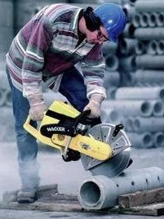
Employees who use cutoff saws must be trained to operate them safely. Review the Owner’s Manual for each model saw that is used. This Toolbox Safety Talk can help review important safety tips.

Work Practices
Review the Owner’s Manual for each model cut-off saw you use.

Inspect each saw before use:
- Blade not cracked, chipped, or warped.
- Use the correct blade for the material and conditions being cut.
- Match saw RPM with blade RPM.
- Machine guards (belt and blade guards) are secure and adjusted.
- Verify the throttle and stop switch are working.
- Fuel added when the saw is cold.

Prevent Kick-back:
- Always keep two hands on the saw. Never operate with one hand.
- Never cut above shoulder height.
- Do not bend over the blade when cutting.
- Support the material being cut to prevent pinching or binding of the wheel.
- Do not grind or bevel on the side of the wheel.
- Release pressure on the cut-off saw as you reach the end of the cut.
- Review the owner’s manual to understand directional forces on the wheel.
- Position your body to keep clear of the wheel and reactive forces.

Work Safely:
- Start saw when resting on the ground. Do not “drop start” cut-off saws.
- Wet cut when feasible to reduce dust and reduce the energy of reactive forces on the wheel.
- During transport, do not roll the blade wheel on the ground.

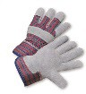

- This can damage the wheel and cause it to shatter during use.

Personal Protective Equipment

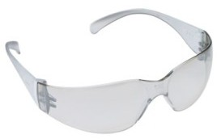
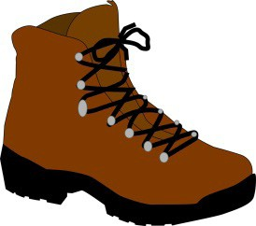
Safety Glasses with Side Shields
Work Gloves
Hearing Protection – earplugs or earmuffs

Boots Tight-fitting respirator with P100 filters when cutting concrete, brick, asbestos cement pipe. Use wet methods to reduce silica or asbestos dust.
Optional:
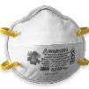
95 mask when cutting metal.

SAFETY TALK SIGN IN SHEET

This form documents that the training specified above was presented to the listed participants. By signing below, each participant acknowledges receiving this training.

Organization:

Trainer: Trainer’s Signature:

Class Participants:

Name: Signature: Date:

Name: Signature: Date:

Name: Signature: Date:

Name: Signature: Date:

Name: Signature: Date:

Name: Signature: Date:

Name: Signature: Date:

Name: Signature: Date:

Name: Signature: Date:

Name: Signature: Date:

Name: Signature: Date:

Name: Signature: Date:

Name: Signature: Date:

Name: Signature: Date:

Name: Signature: Date:

Name: Signature: Date:

Name: Signature: Date:

