
AERIAL LIFT

Work in scissor lifts and elevated platforms is inherently dangerous, and additional hazards can be introduced based on the tasks being performed while elevated. Recognition and control of the present hazards are crucial to assuring a safe and efficient work environment. Below are some safety steps to take to work safely on a scissor lift.
- Do not use a scissor lift without proper training by an authorized person.
- Read the manufacturer/operator’s manual before using a scissor lift.
- Never use ladders or other platforms to gain additional elevation within the scissor lift work area.
- Do not climb on guardrails.
- Do not exceed weight capacity. Check the capacity of each lift you use.
- Always maintain a firm footing while on the platform.
- The scissor lift shall not be positioned against other objects to stabilize.
- Always check the surroundings before moving, raising, or lowering.
- Maintain a safe distance from obstacles, debris, drop-off holes, and other hazards.
- Always lock the wheels when using the scissor lift on an incline.
- Limit travel speed according to conditions, congestion, and visibility.
- Watch for personnel in the area, and rope off your work area whenever possible.
- Watch for overhead obstacles.
- Report problems or malfunctions immediately.
- Do not operate a malfunctioning scissor lift until corrective action or repairs have been completed.

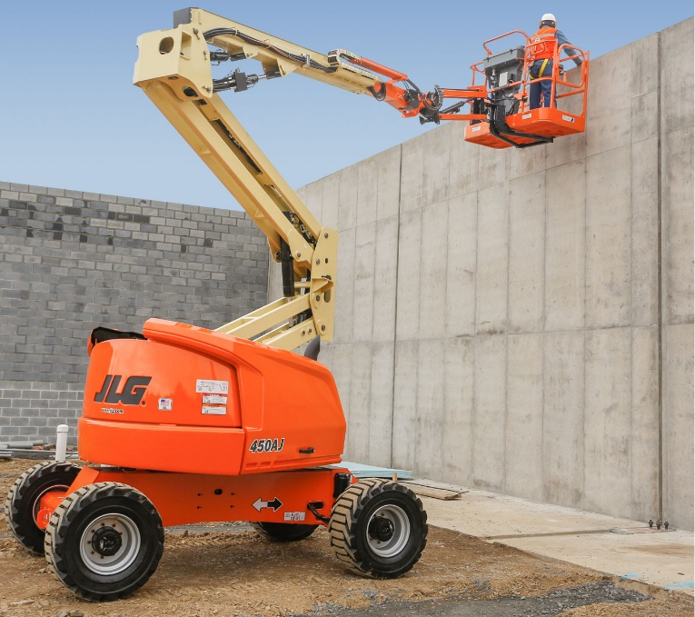
SAFETY TALK SIGN IN SHEET

This form documents that the training specified above was presented to the listed participants. By signing below, each participant acknowledges receiving this training.

Organization:

Trainer: Trainer’s Signature:

Class Participants:

Name: Signature: Date:

Name: Signature: Date:

Name: Signature: Date:

Name: Signature: Date:

Name: Signature: Date:

Name: Signature: Date:

Name: Signature: Date:

Name: Signature: Date:

Name: Signature: Date:

Name: Signature: Date:

Name: Signature: Date:

Name: Signature: Date:

Name: Signature: Date:

Name: Signature: Date:

Name: Signature: Date:

Name: Signature: Date:

Name: Signature: Date:

