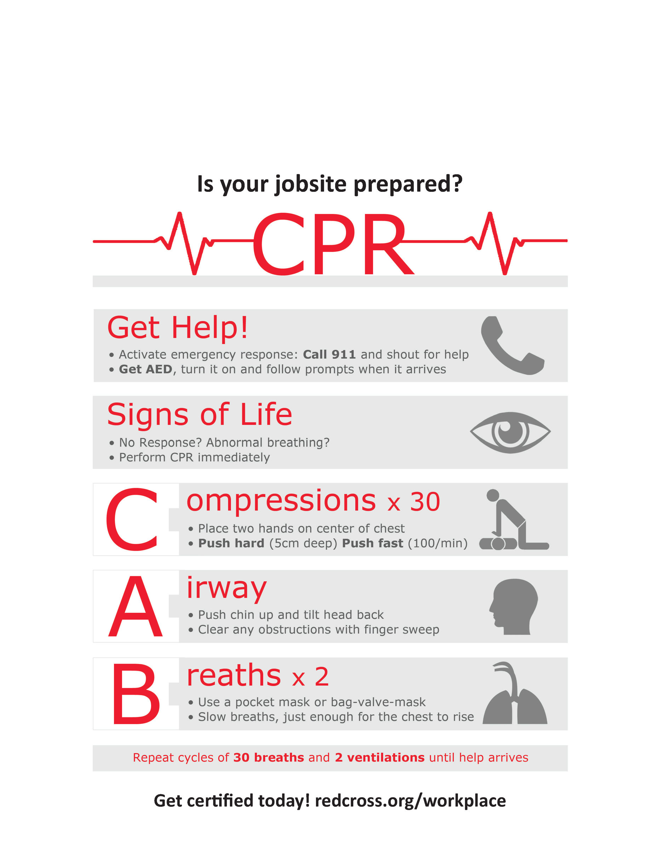**­­­In Partnership with­­­­**

Agency Line One

Agency Contact Line Two

Agency Contact Line Three

**­­**



**­**