**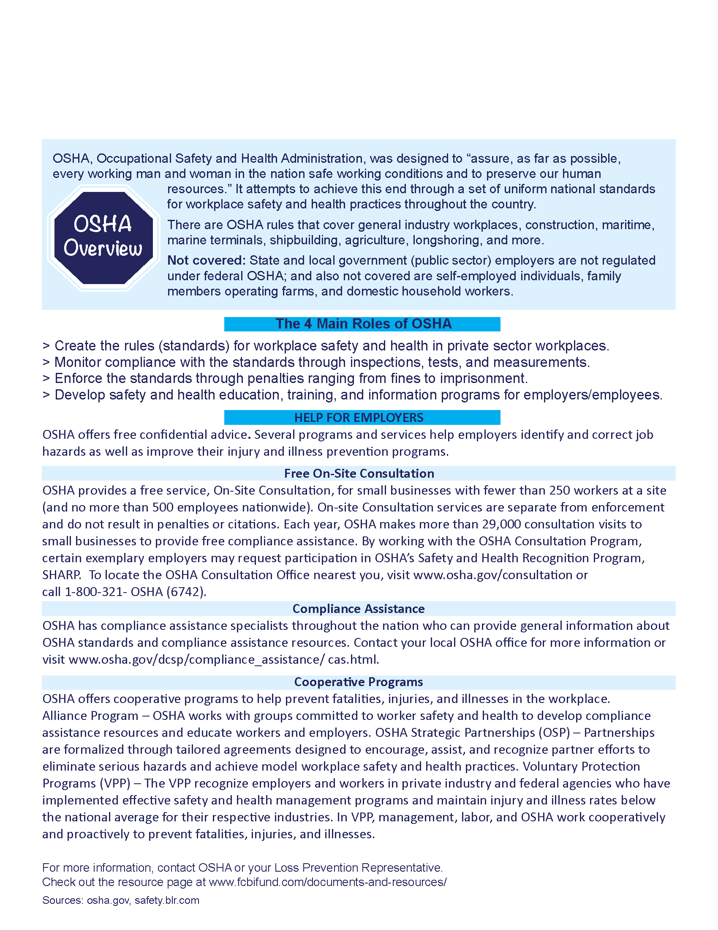****­­­In Partnership with**

Agency Line One

Agency Contact Line Two

Agency Contact Line Three

**­**

